S3 bucket auto cleaning

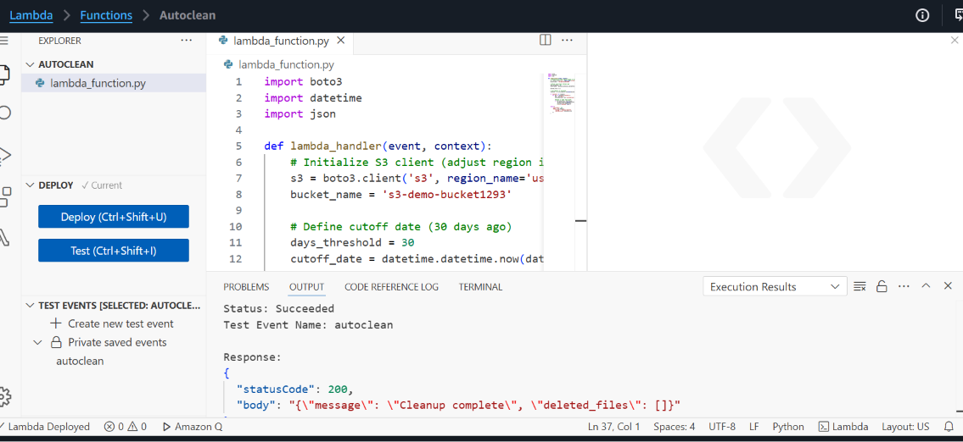

Lambda function:

import boto3
import datetime
import json

def lambda_handler(event, context):
# Initialize S3 client (adjust region if needed)
s3 = boto3.client('s3', region_name='us-east-1')
bucket_name = 's3-demo-bucket1293'

# Define cutoff date (30 days ago)
days_threshold = 30
cutoff_date = datetime.datetime.now(datetime.timezone.utc) - datetime.timedelta(days=days_threshold)

deleted_files = []

# List objects in the bucket
response = s3.list_objects_v2(Bucket=bucket_name)

if 'Contents' in response:
for obj in response['Contents']:
key = obj['Key']
last_modified = obj['LastModified']

# Delete if older than cutoff
if last_modified < cutoff_date:
s3.delete_object(Bucket=bucket_name, Key=key)
deleted_files.append(key)
print(f"Deleted: {key}")

return {
'statusCode': 200,
'body': json.dumps({
'message': 'Cleanup complete',
'deleted_files': deleted_files
})
}

Bucket:

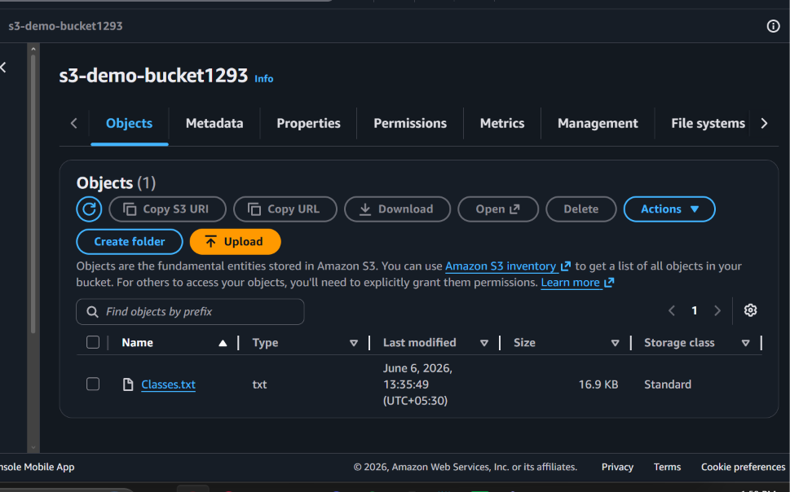

IAM Role:

